Ques: Create a SSIS package that transfer notepad file to SQL Server

Ans:

Input

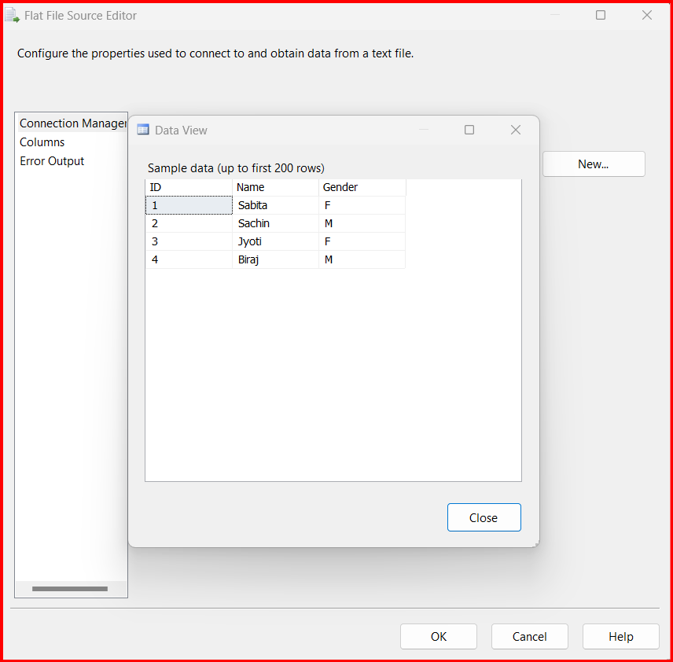

Output

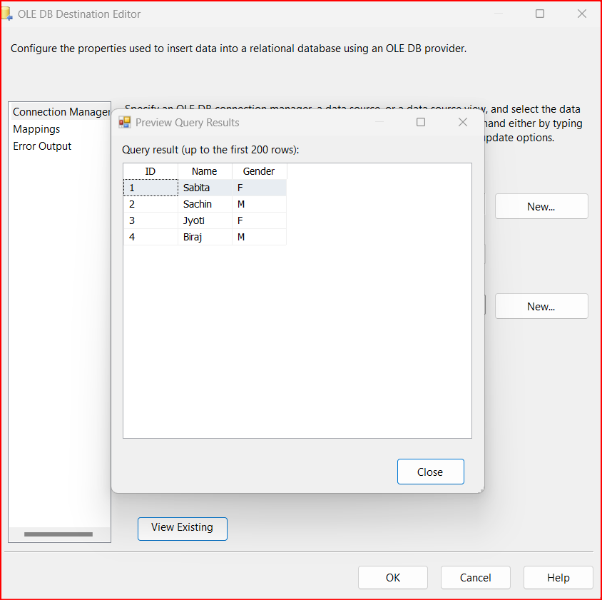

Execution:

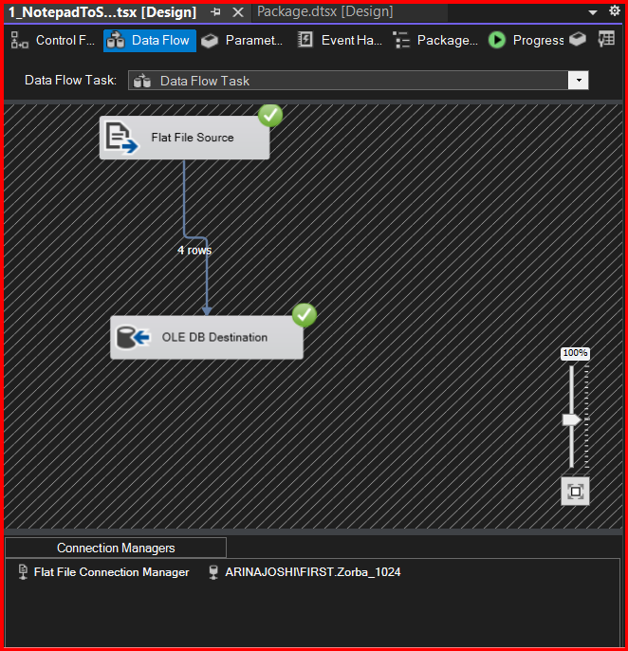

Save in filename: <Your Name>_ <Test_Date>_<Batch_Name>, eg: Arina Joshi_1June_SQL1024

Ques : Create a SSIS package that transfer 3 text file data into SQL Server table using Merge

Ans:

Input1

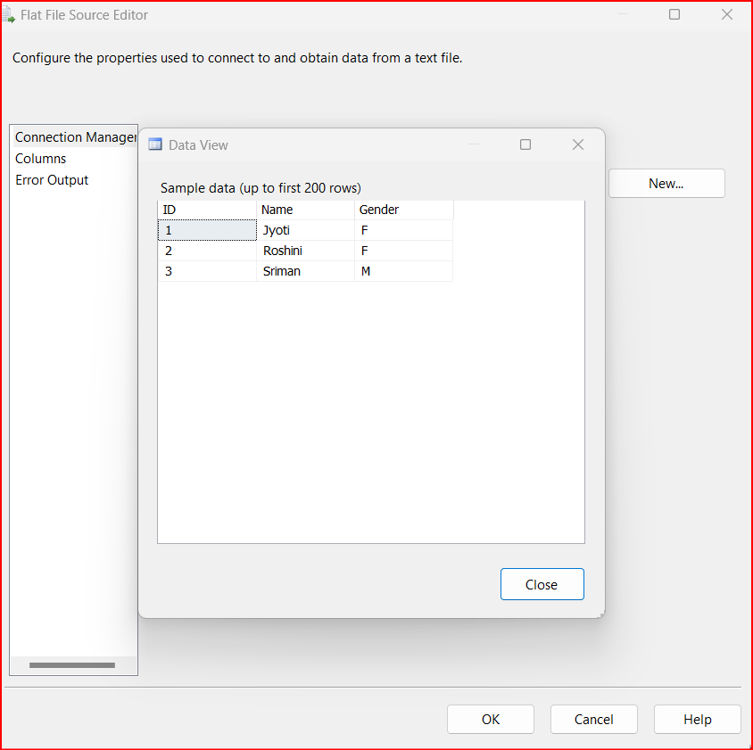

Input2

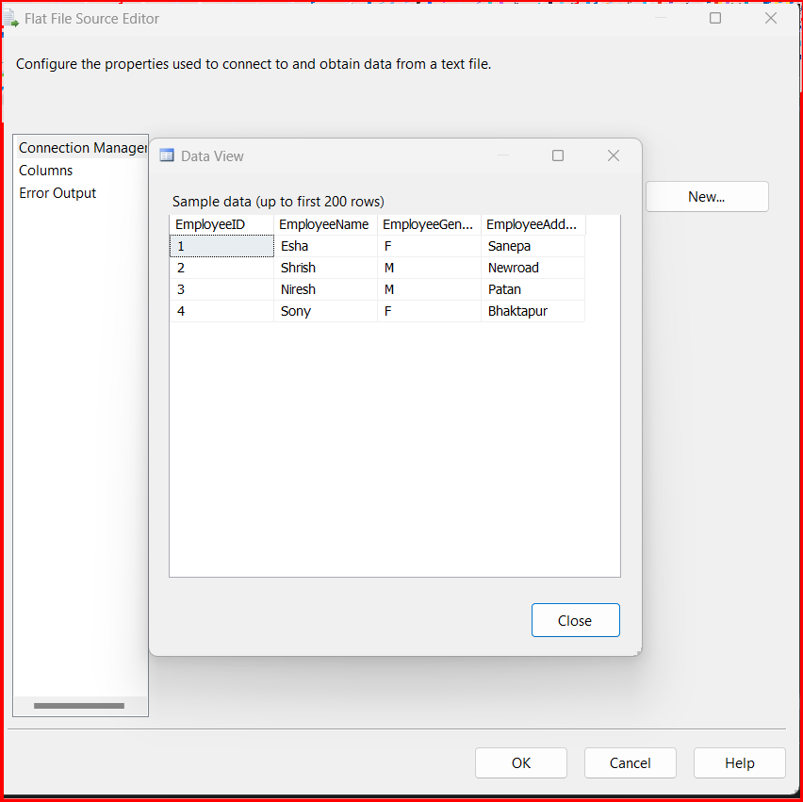

Input3

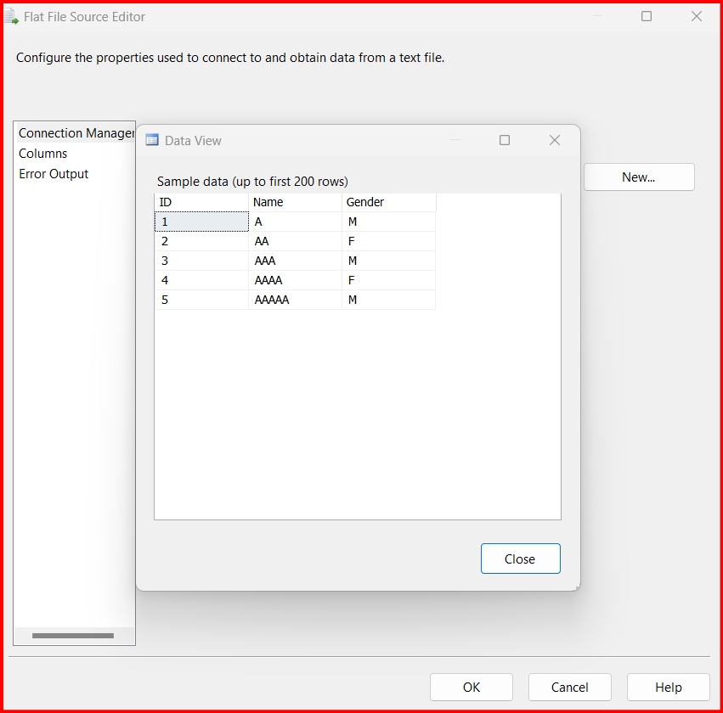

Execution:

